**Project Development Phase**

**Sprint – 3**

|  |  |
| --- | --- |
| Date | 15 November 2022 |
| Team ID | PNT2022TMID45183S |
| Project Name | AI Based Discourse for Banking Industry |
| Maximum Marks | 8 Marks |

# Testing & Deployment Phase I

## Preview of the Chatbot

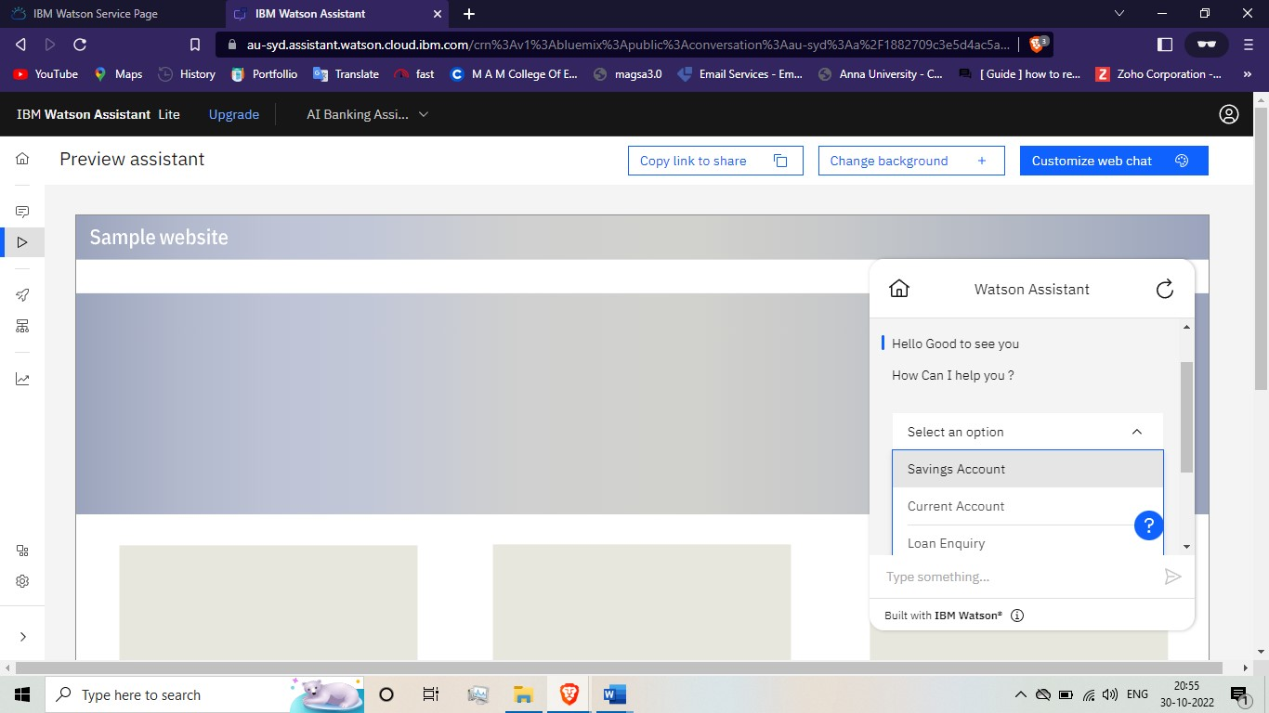

## Test the chatbot

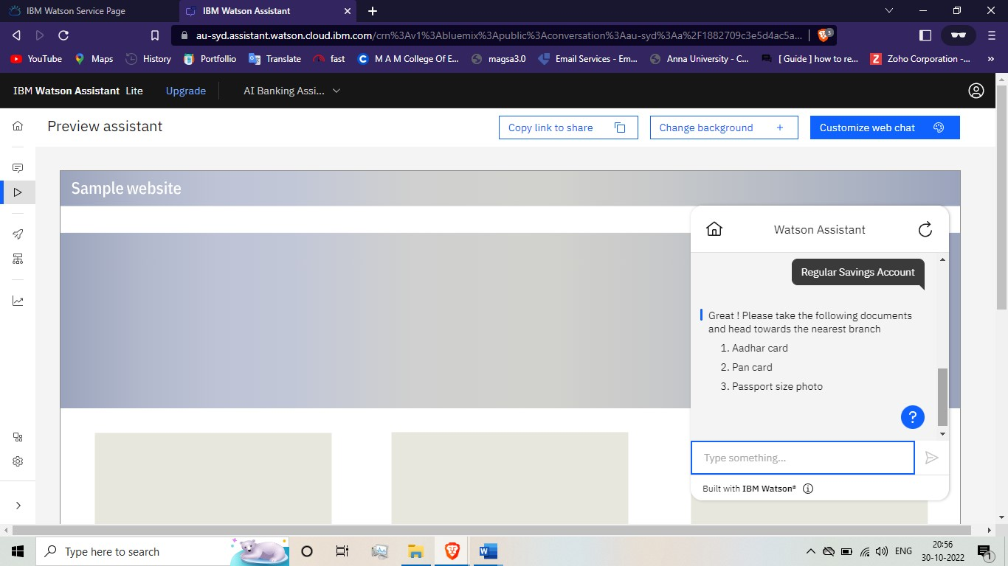

## Test the different action performance

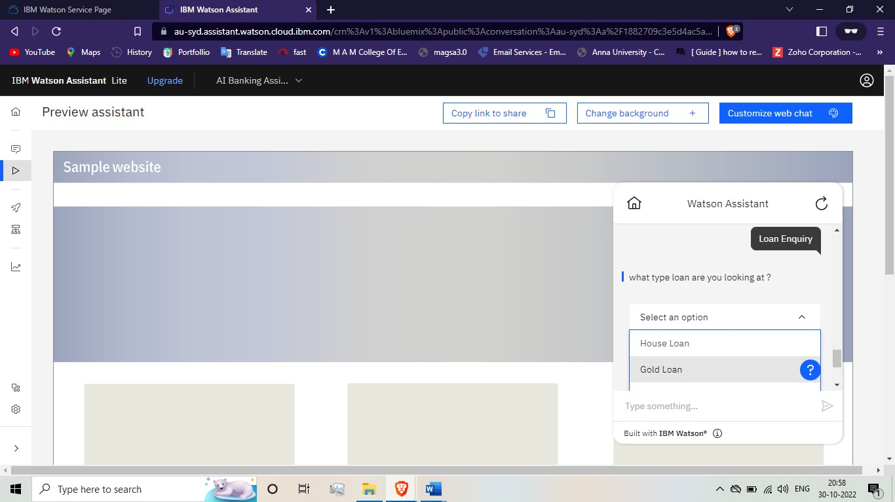

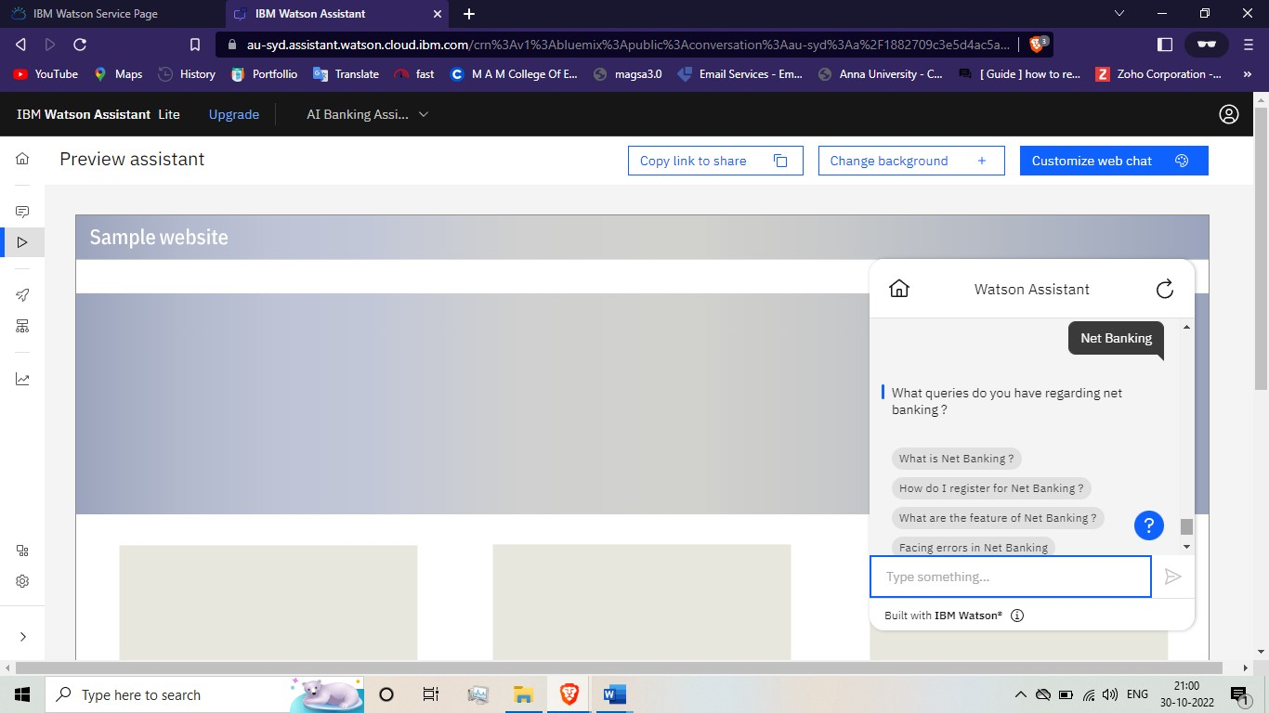

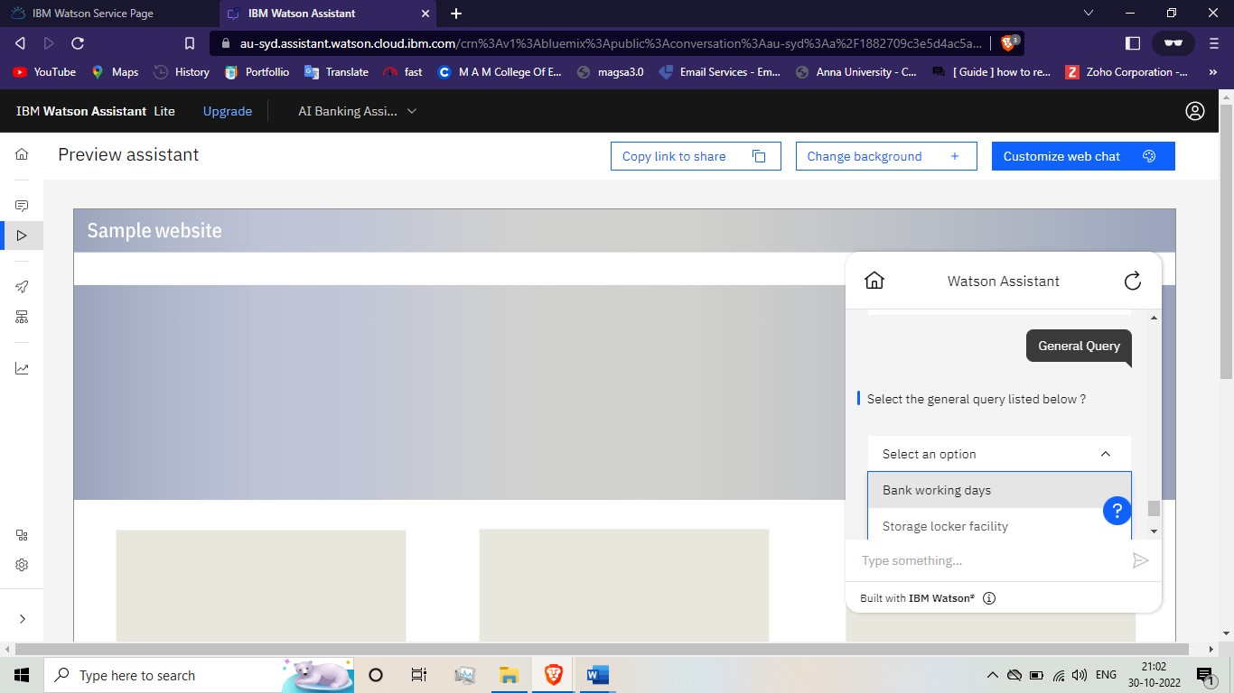

**Develop the Python Script:**

## app.py

from flask import Flask, render_template app = Flask(__name__)

@app.route('/') def bot():

return render_template('chatbot.html')

if __name__ == '__main__':

app.debug = True app.run()